Practical 11: Student Management CRUD with Search and Filter
Problem Definition Create a student management module to add, view, edit, delete, search and
filter student records. All database operations must use MYSQLi
statements and clear success/failure messages.

Theory :

Key Questions / Analysis / Interpretation
1. Are SELECT, INSERT, UPDATE, and DELETE operations working?
Yes. These SQL operations are used to retrieve, insert, update, and delete records in the database.
2. Is search by name/email/course implemented?
Yes. The search functionality allows users to find records using a name, email address, or course.
3. Are delete operations confirmed before execution?
Yes. A confirmation message is displayed before deleting a record to prevent accidental deletion.
Implementation/out put/result:
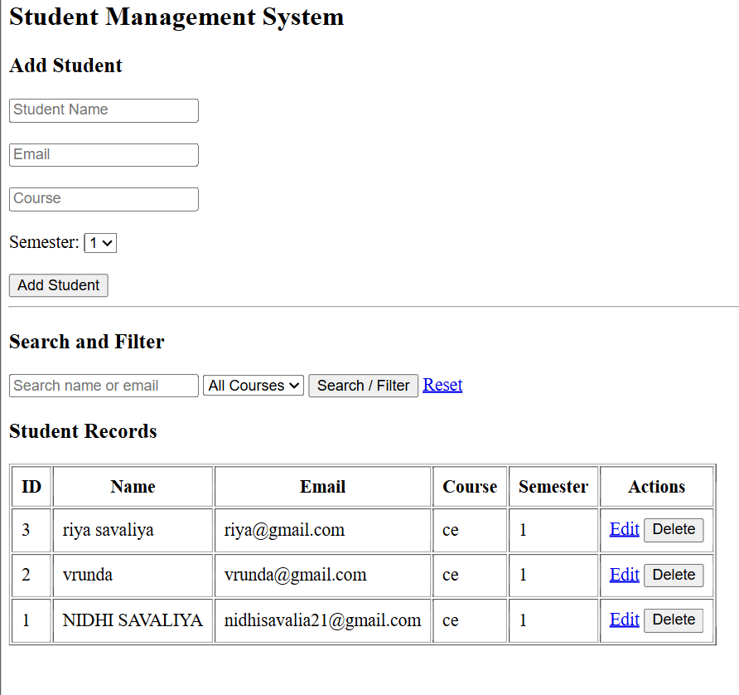
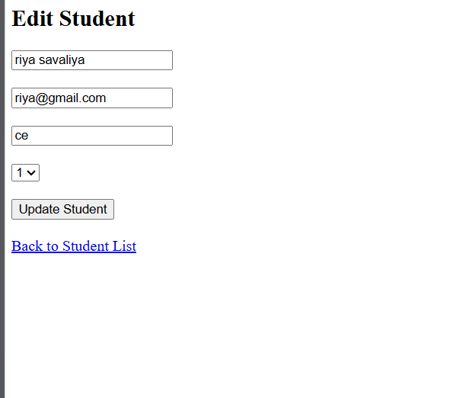
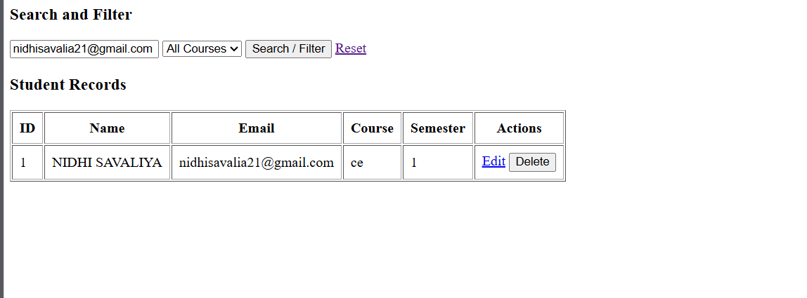

Git hub link:
https://github.com/nidhisavalia/25dce103-web

Learning outcomes:

Learned to perform CRUD operations (Create, Read, Update, and Delete) using PHP and MySQLi.
Learned to add, view, edit, and delete student records.
Learned to search student records by name, email, and course.
Learned to filter student records by course.
Learned to use MySQLi prepared statements for secure database operations.
Learned to display success and error messages and confirm before deleting records.

Faculty remarks:

